**1)go on this link to download eclipse**

Download Eclipse Installer from [http://www.eclipse.org/downloads](https://eclipse.org/downloads)

Eclipse is hosted on many mirrors around the world. Please select the one closest to you and start to download the Installer

**2. run this file**

Start the Eclipse Installer executable. You may get a security warning to run this file. If the Eclipse Foundation is the Publisher, you are good to select Run.

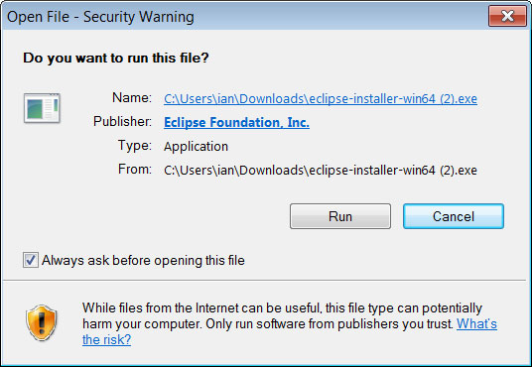

**3. Select the package to install**

Select and click on the package you want to install.

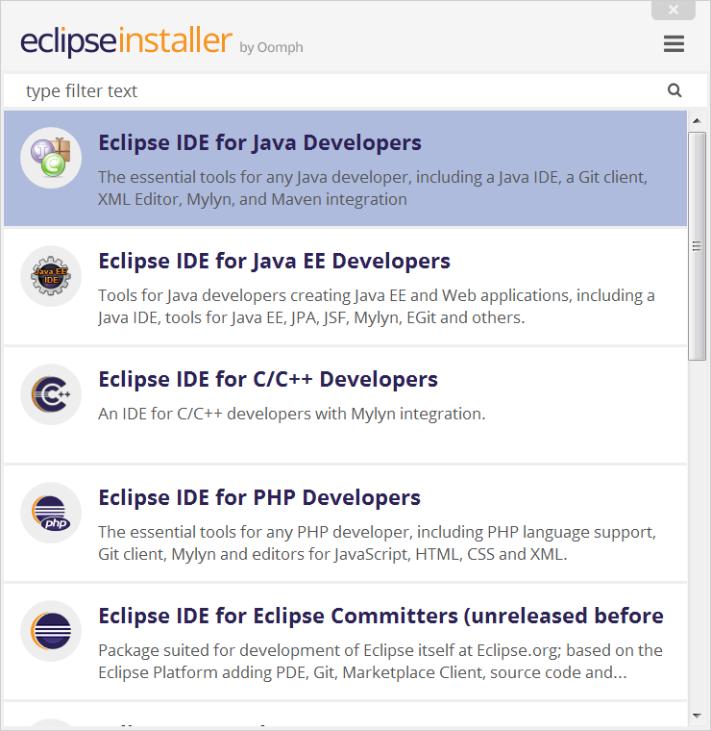

**4. Select your installation folder**

Specify the folder where you want Eclipse to be installed.

Select the ‘Install’ button to begin the installation.

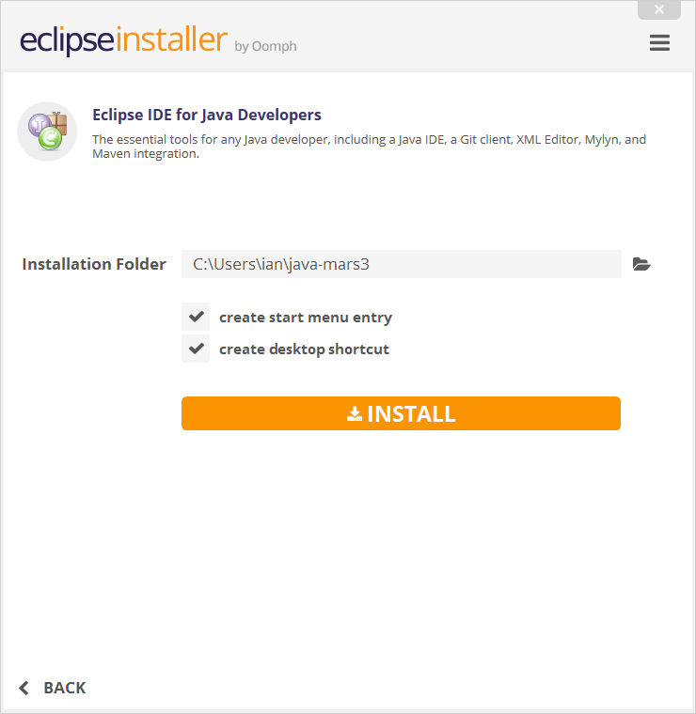

**5. Launch Eclipse**

